### Compress All Tables & Indexes in a DB – SQL Server.

<https://sites.google.com/site/williambrownw/it/sql-server/handy-sql/compress-all-tables-and-indexes-in-a-database>

**Scenario-1: This EXECUTES & ENABLES all Tables & Indexes Compression at PAGE Level**

/*

**Run in the database that will be compressed with CONDITION DATA_COMPRESSION=PAGE**

*/

use AdventureWorks2012 --CHANGE YOUR DBNAME HERE TO COMPRESS Table & Indexes with CONDITION DATA_COMPRESSION=PAGE

go

DECLARE @sqlcmd nvarchar(1000)

DECLARE compress_cursor CURSOR FOR

SELECT DISTINCT 'ALTER TABLE ' + '[' + s.[name] + ']'+'.' + '[' + o.[name] + ']' + ' REBUILD WITH (DATA_COMPRESSION=PAGE);'

FROM sys.objects AS o WITH (NOLOCK)

INNER JOIN sys.indexes AS i WITH (NOLOCK)

ON o.[object_id] = i.[object_id]

INNER JOIN sys.schemas AS s WITH (NOLOCK)

ON o.[schema_id] = s.[schema_id]

INNER JOIN sys.dm_db_partition_stats AS ps WITH (NOLOCK)

ON i.[object_id] = ps.[object_id]

AND ps.[index_id] = i.[index_id]

WHERE o.[type] = 'U'

UNION ALL

SELECT 'ALTER INDEX '+ '[' + i.[name] + ']' + ' ON ' + '[' + s.[name] + ']' + '.' + '[' + o.[name] + ']' + ' REBUILD WITH (DATA_COMPRESSION=PAGE);'

FROM sys.objects AS o WITH (NOLOCK)

INNER JOIN sys.indexes AS i WITH (NOLOCK)

ON o.[object_id] = i.[object_id]

INNER JOIN sys.schemas s WITH (NOLOCK)

ON o.[schema_id] = s.[schema_id]

INNER JOIN sys.dm_db_partition_stats AS ps WITH (NOLOCK)

ON i.[object_id] = ps.[object_id]

AND ps.[index_id] = i.[index_id]

WHERE o.type = 'U' AND i.[index_id] >0

OPEN compress_cursor;

FETCH NEXT FROM compress_cursor INTO @sqlcmd

WHILE @@FETCH_STATUS = 0

BEGIN

PRINT @sqlcmd

EXEC sp_executesql @sqlcmd

FETCH NEXT FROM compress_cursor INTO @sqlcmd

END

CLOSE compress_cursor

DEALLOCATE compress_cursor

**SAMPLE OUTPUT:**

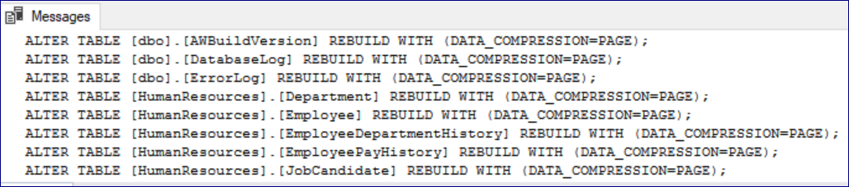

**Scenario-2: This EXECUTES & ENABLES all Tables & Indexes Compression at ROW Level**

/*

**Run in the database that will be compressed with CONDITION DATA_COMPRESSION=ROW**

*/

use AdventureWorks2012 --CHANGE YOUR DBNAME HERE TO COMPRESS Table & Indexes with CONDITION DATA_COMPRESSION=ROW

go

DECLARE @sqlcmd nvarchar(1000)

DECLARE compress_cursor CURSOR FOR

SELECT DISTINCT 'ALTER TABLE ' + '[' + s.[name] + ']'+'.' + '[' + o.[name] + ']' + ' REBUILD WITH (DATA_COMPRESSION=ROW);'

FROM sys.objects AS o WITH (NOLOCK)

INNER JOIN sys.indexes AS i WITH (NOLOCK)

ON o.[object_id] = i.[object_id]

INNER JOIN sys.schemas AS s WITH (NOLOCK)

ON o.[schema_id] = s.[schema_id]

INNER JOIN sys.dm_db_partition_stats AS ps WITH (NOLOCK)

ON i.[object_id] = ps.[object_id]

AND ps.[index_id] = i.[index_id]

WHERE o.[type] = 'U'

UNION ALL

SELECT 'ALTER INDEX '+ '[' + i.[name] + ']' + ' ON ' + '[' + s.[name] + ']' + '.' + '[' + o.[name] + ']' + ' REBUILD WITH (DATA_COMPRESSION=ROW);'

FROM sys.objects AS o WITH (NOLOCK)

INNER JOIN sys.indexes AS i WITH (NOLOCK)

ON o.[object_id] = i.[object_id]

INNER JOIN sys.schemas s WITH (NOLOCK)

ON o.[schema_id] = s.[schema_id]

INNER JOIN sys.dm_db_partition_stats AS ps WITH (NOLOCK)

ON i.[object_id] = ps.[object_id]

AND ps.[index_id] = i.[index_id]

WHERE o.type = 'U' AND i.[index_id] >0

OPEN compress_cursor;

FETCH NEXT FROM compress_cursor INTO @sqlcmd

WHILE @@FETCH_STATUS = 0

BEGIN

PRINT @sqlcmd

EXEC sp_executesql @sqlcmd

FETCH NEXT FROM compress_cursor INTO @sqlcmd

END

CLOSE compress_cursor

DEALLOCATE compress_cursor

**SAMPLE OUTPUT:**

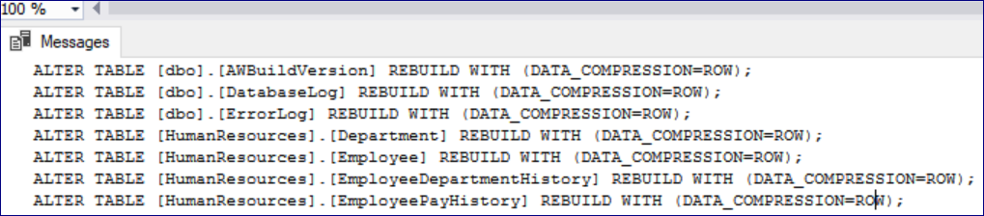

**Scenario-3: This EXECUTES & DISABLES all Tables & Indexes Compression. (Removes Compression)**

/*

**Run in the database that will be compressed with CONDITION DATA_COMPRESSION=NONE**

*/

use AdventureWorks2012 --CHANGE YOUR DBNAME HERE To Remove Compression of all Tables & Indexes.

go

DECLARE @sqlcmd nvarchar(1000)

DECLARE compress_cursor CURSOR FOR

SELECT DISTINCT 'ALTER TABLE ' + '[' + s.[name] + ']'+'.' + '[' + o.[name] + ']' + ' REBUILD WITH (DATA_COMPRESSION=NONE);'

FROM sys.objects AS o WITH (NOLOCK)

INNER JOIN sys.indexes AS i WITH (NOLOCK)

ON o.[object_id] = i.[object_id]

INNER JOIN sys.schemas AS s WITH (NOLOCK)

ON o.[schema_id] = s.[schema_id]

INNER JOIN sys.dm_db_partition_stats AS ps WITH (NOLOCK)

ON i.[object_id] = ps.[object_id]

AND ps.[index_id] = i.[index_id]

WHERE o.[type] = 'U'

UNION ALL

SELECT 'ALTER INDEX '+ '[' + i.[name] + ']' + ' ON ' + '[' + s.[name] + ']' + '.' + '[' + o.[name] + ']' + ' REBUILD WITH (DATA_COMPRESSION=NONE);'

FROM sys.objects AS o WITH (NOLOCK)

INNER JOIN sys.indexes AS i WITH (NOLOCK)

ON o.[object_id] = i.[object_id]

INNER JOIN sys.schemas s WITH (NOLOCK)

ON o.[schema_id] = s.[schema_id]

INNER JOIN sys.dm_db_partition_stats AS ps WITH (NOLOCK)

ON i.[object_id] = ps.[object_id]

AND ps.[index_id] = i.[index_id]

WHERE o.type = 'U' AND i.[index_id] >0

OPEN compress_cursor;

FETCH NEXT FROM compress_cursor INTO @sqlcmd

WHILE @@FETCH_STATUS = 0

BEGIN

PRINT @sqlcmd

EXEC sp_executesql @sqlcmd

FETCH NEXT FROM compress_cursor INTO @sqlcmd

END

CLOSE compress_cursor

DEALLOCATE compress_cursor

**SAMPLE OUTPUT:**

